Data Flow Diagrams & User Stories

Date: 07 Mar 2026
Team ID: [69a6a9a7f713ea4f3da55fa1]
Project Name: [Micro Goal]
Maximum Marks: 4

- Overview
- Project Design Phase II
- Data Flow Diagram & User Stories
- Date: February 16, 2026
- Project Name: [Enter Project Name]
- Team ID: [Enter Team ID]
- Micro Goal: [Enter Micro Goal]
- Maximum Marks: 4
- Data Flow Diagram (DataFlowDiagrams)
- Express.js HTTP Request Flow with MongoDB
- Key Components:
  - Express Server
  - Routes
  - Middleware Layer
  - Auth Middleware
  - Error Middleware
  - Controllers
  - Models
  - MongoDB Database
  - JSONResponse
  - User
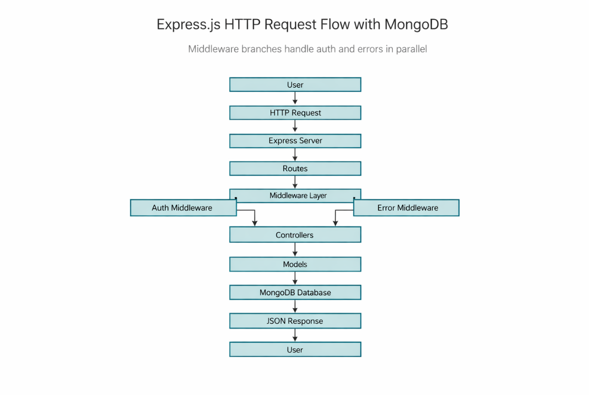
- User Stories – MicroGoals Backend API
User Type: Customer (Web User) and Developer/Admin
- USN-1: Registration
  - As a user, I want to register an account so that I can access the system.
  - Acceptance: User data stored in the database; success response returned.
  - Priority: High
  - Release: Sprint-1
- USN-2: Login
  - As a user, I want to log in securely so I can access my personal goals.
  - Acceptance: Valid email/password; JWT token; status 200.
  - Priority: High
  - Release: Sprint-1
- USN-3: Create Goal
  - As a user, I want to create a new goal to manage my tasks.
  - Acceptance: Goal saved in database; 201 Created.
  - Priority: High
  - Release: Sprint-1
- USN-4: View Goals
  - As a user, I want to view my goals to track progress.
  - Acceptance: Only authenticated users can access their own goals.
  - Priority: High
  - Release: Sprint-1
- USN-5: Update Goal
  - As a user, I want to update an existing goal.
  - Acceptance: Updated goal saved in database.
  - Priority: High
  - Release: Sprint-1
- USN-6: Delete Goal
  - As a user, I want to delete a goal.
  - Acceptance: Goal permanently deleted; success response.
  - Priority: High
  - Release: Sprint-1
- USN-7: Data Protection
  - As a user, I want my data protected from other users.
  - Acceptance: Unauthorized access yields 401 error.
  - Priority: High
  - Release: Sprint-1
- USN-8: API Testing
  - As a developer, I want to test API endpoints to ensure they work.
  - Acceptance: Correct responses and status codes in Thunder Client.
  - Priority: Medium
  - Release: Sprint-2
- USN-9: Centralized Error Handling
  - As a developer, I want centralized error handling to manage errors efficiently.
  - Acceptance: Errors handled via middleware with proper messages.
  - Priority: Medium
  - Release: Sprint-2
- Acceptance Criteria & Priorities
- USN-1 to USN-9 with the Acceptance Criteria and Priority as listed above.
- Middleware & Security
- Auth Middleware
- Error Middleware
- Access Control
- 401 Unauthorized handling
- API Testing
- Tools: Thunder Client (as referenced)
- Endpoints validation, status codes, and error handling expectations
- Data & Models
- MongoDB Database
- Controllers
- Models
- JSONResponse format
- Conclusion
- Summary: This document captures the backend API goals, data flow, and middleware design for Sprint-1 and Sprint-2.
- Next Steps: Implement endpoints, wire up middleware, write tests, and validate with Thunder Client.

